A Child is Born Series
“Mighty God”

Introduction:

During the Advent Season we are Isaiah’s prophecy in Isaiah chapter 9 where the prophet tells us, “For a child will be born to us, a son will be given to us; And the government will rest on His shoulders; And His name will be called Wonderful Counselor, Mighty God, Eternal Father, Prince of Peace.” (Is.9.6-7)

As we had discovered this prophecy was given 700 years before Christ was born. The prophecy was originally given to the people of Israel as they sat in the gloom and anguish of an impending invasion of the brutal Assyrian army. In the midst of their despair God reminds His people of His covenant promise to send a Redeemer. (Gen.3.15) God will send a child to conquer the hearts of nations.

Even though the nations are in uproar and kings of the earth are taking their stand, God reminds His people that He has installed His King upon Zion and has given His King the nations as an inheritance. (Ps.2.1-9) God reminds His people that no matter how dark things might be, this King will establish His Kingdom, the Kingdom of God, and there will be no end of the increase of His government or of peace. (Is.9.7)

Matthew’s Gospel confirms that this prophecy is telling us about the life and ministry of Jesus Christ. (Mt.4.15-16) This child is the Christ Child. This son is the Son of God. Isaiah tells us, “His name will be called Wonderful Counselor, Mighty God, Eternal Father, Prince of Peace.” (vs.6b) Isaiah brings together four concise names that appear nowhere else in the Bible. Nowhere else in Scripture do we find names for Christ crowded together like we do in verse six. It has been said that this is the greatest single verse in all of Scripture describing the Lord Jesus Christ. These four names capture the total person and work of Jesus, who He is and what He does.
These names described with absolute perfection the person and ministry of Jesus. Jesus is my Wonderful Counselor who brings guidance to my confusion. Jesus is my Mighty God who rescues me from chaos. Jesus is my Eternal Father who showers me with compassion. Jesus is my Prince of Peace who resolves my conflicts.

A Child is Born . . . A Son is Given

The Prophet tells us, “a child will be born to us, a son will be given to us.” Isaiah had prophesied earlier in chapter 7, “the Lord Himself will give you a sign: Behold, a virgin will be with child and bear a son, and she will call His name Immanuel,” which means “God with us.” (Is.7.14) Isaiah is telling us this child was not an ordinary child but rather this child will be Immanuel, which means “God with us.” (Is.7.14) This child is God in the flesh. The majesty of the manger of Bethlehem is the Christ child born without discarding His deity or distorting humanity.

The incarnation of the Son of God was the true wedding of perfect deity and sinless humanity. The Godhead and manhood were inseparably joined together in one person, without conversion, composition, or confusion. This child is very God, and very man, yet one Christ, the only Mediator between God and man. (WCF 7.2) The fact that Jesus was God in the flesh was blasphemy for the religious leaders of His day. (Lk.5.21) These leaders were looking for the Messiah but they were blinded to the prophecies of the Old Testament telling us that the child would be God with us.

Even the phrase “a child is born . . . a son is given” emphasizes His humanity together with His deity. The phrase “a child is born” emphasizes His humanity while the phrase “a son is given” emphasizes His deity.

“A child is born” speaks of Jesus’ earthly beginning in the stable in Bethlehem. The Bible tells us that in as much as humanity consists of flesh and blood, so Christ Jesus likewise shared the same. (Heb.2.14) The Bible tells us “when the fullness of time had come, God sent forth His Son, born of a woman, born under the law.” (Gal.4.4) This phrase “a child is born” emphasizes Jesus’ humanity.

“A son is given” speaks of His eternal being. Notice the text is quite specific, quite clear. It does not say, “a child is born, a son is born.” No, “a child is born and a son is given. God the Father’s Christmas gift is the giving of His Son. “For God so loved the world that He gave His only begotten Son.” (Jn.3.16) The birth in Bethlehem was not His beginning but rather it was the Father’s declaration, “Thou art My Son, today I have begotten Thee.” (Ps.2.7; Heb.1.5) This phrase “a son is given” emphasizes Jesus’ deity.

As a matter of fact, each of the four names in Isaiah nine captures the majesty of the perfect God-man. Wonderful emphasizes His deity while Counselor emphasizes His humanity. Mighty emphasizes His humanity while God emphasizes His deity. Eternal emphasizes His deity while Father emphasizes His humanity. Prince emphasizes His humanity while Peace emphasizes His deity. Truly, Jesus is “God with us” our “mighty God.”

Mighty God

As we consider the four names given in Isaiah nine, this morning our focus will be how Jesus Christ is our Mighty God. The story is told about a popular bodybuilder being interviewed on a national television show. The bodybuilder was introduced and as he was walking to take his seat to be interviewed he flexed his muscles and the crowd went crazy with applause. When he sat down the interviewer asked him, “What do you use all those muscles for?” Puzzled by the question the bodybuilder stood up and flexed his muscles again and again the crowd went wild with applause. After things quieted down the interviewer asked, “What do you use all of those muscles for?” Now frustrated the bodybuilder once again stood and flexed his muscles to a cheering audience.

The point is that the bodybuilder had a lot of show but no substance. The body builder reminds me of the gods of this world that have mouths, but they cannot speak; They have eyes, but they cannot see; They have ears, but they cannot hear; They have noses, but they cannot smell; They have hands, but they cannot feel; They have feet, but they cannot walk; They cannot make a sound with their throat. (Ps.155.5-7) A lot of show but no substance.

The body builder is all pump up with no power. I know that Jesus is often represented as a “90 pound weakling” but God wants us to know that the child that is born and the son that is given is a mighty warrior. People want a God that is mighty. I’ve never met a person that wants a wimpy God. Why do you think when people go through a crisis they call out to God for help? Because people believe in a mighty God.

The Hebrew term for “mighty” means “champion” or “hero.” Mighty God conjures up warfare and battleground imagery. The child born to us, the son given to us is a warrior God, a hero God who conquers all of His and our enemies. His strength is not for show but to rescue us from the chaos.

Just listen to the vision of Christ shown to the Apostle John in the book of Revelation:

And I saw heaven opened, and behold, a white horse, and He who sat on it is called Faithful and True, and in righteousness He judges and wages war.

From His mouth comes a sharp sword, so that with it He may strike down the nations, and He will rule them with a rod of iron; and He treads the wine press of the fierce wrath of God, the Almighty. And on His robe and on His thigh He has a name written, “KING OF KINGS, AND LORD OF LORDS.”

He has sounded forth the trumpet that shall never call retreat;
He is sifting out the hearts of men before His judgment seat;
O be swift, my soul, to answer Him; be jubilant, my feet!
Our God is marching on.
(Battle Hymn of the Republic)

Remember the context of Isaiah nine was that the Israel were facing attack from the Assyrian army who were vicious and brutal. As Israel sat discouraged by the dread of defeat the Lord declares that He is in their midst and He is a victorious warrior. (Zeph.3.17) The people of God might feel beaten but the Lord reminds them that the battle is the Lord’s and He goes forth conquering, and to conquer. (ISam.17.47; Rev.6.2) The Christ Child will overcome those who attack His people because He is Lord of lords and King of kings. (Rev.17.14) He is our Mighty God!

The Lord is mighty over events, enemies, and evil that seeks to attack us. The Lord is mighty over events that seem to overwhelm us. The Lord is mighty over enemies that seek to harm us. The Lord is mighty over evil that seeks to capture us. What are the events, enemies, or evil that is attacking your life? The Lord speaks in righteousness declaring that He is mighty to save. (Is.63.1) Is there an upcoming meeting or interview that has you frighten? The Lord is mighty to save! Is there co-worker or official that is causing you to fear? The Lord is mighty to save! Is there a temptation or addiction that is threatening you? The Lord is mighty to save!

Have you not known? Have you not heard? The LORD is the everlasting God, the Creator of the ends of the earth. He does not faint or grow weary; His understanding is unsearchable. He gives power to the faint, and to him who has no might He increases strength. Even youths shall faint and be weary, and young men shall fall exhausted; but they who wait for the LORD shall renew their strength; they shall mount up with wings like eagles; they shall run and not be weary; they shall walk and not faint. (Is.40.28-31)

The Lord Jesus Christ is a mighty God who recuses us from chaos! There is an episode in the Gospels of Jesus healing a paralyzed man. (Mt.9.1-8; Mk.2.1-12; Lk.5.17-26) But before Jesus healed the man He said to him, “Friend, your sins are forgiven you.” Now the scribes and the Pharisees didn’t like that Jesus said this because only God can forgive sins. Jesus knowing their hearts asks, “Which is easier, to say, ‘Your sins have been forgiven you’ or to say, ‘Rise and walk.’” Jesus’ point is that both are impossible for man but not for the Mighty God. But, so that you may know that the Son of Man has authority on earth to forgive sins,”—He said to the paralytic—“I say to you, get up, and pick up your stretcher and go home.” Jesus, the mighty Son of God, has the authority to forgive you sins, heal your diseases, and to govern the affairs of our lives.

Brothers and Sisters remember Jesus said, “All authority has been given to Me in heaven and on earth. (Mt.28.18) Not some authority but all authority and not just in heaven but also on earth!

Jesus is seated at the right hand of the Father in heavenly places, far above all rule and authority and power and dominion, and every name that is named, not only in this age but also in the one to come. And He put all things in subjection under His feet. (Eph.1.20-22) Not some things are in subjection under His feet but all things and not just for this age but also for the one to come!

I want to ask you, to which of the angels has the Father ever said, “Sit at My right hand, Until I make Your enemies A footstool for Your feet”? (Heb.1.13) None! The Father has only said this to His Son because His Son, our Lord Jesus Christ, is our Mighty God!

Closing Thought

For the past several years I have had the privilege to host the Cypress Bay Football Team here at the church on Thursday afternoon for what we called “Team Respect.” Team Respect focuses on character development and team building using stories from the Old Testament, current sport figures, and people in the news. Every year I would take the opportunity to tell the players the story about one of the Metal of Honor recipients for that year.

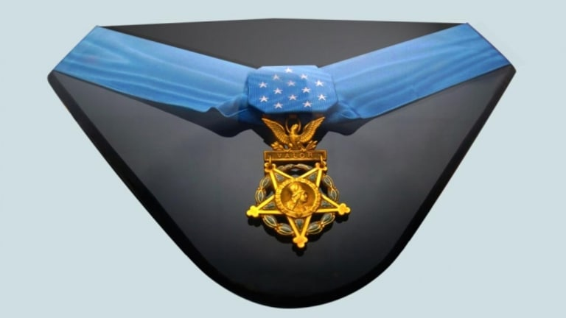

The Medal of Honor is the United States of America's highest and most prestigious personal military decoration that is awarded to recognize U.S. military service members who have distinguished themselves by acts of valor.

Let me share just one story of a Vietnam Veteran: Gunnery Sergeant Canley

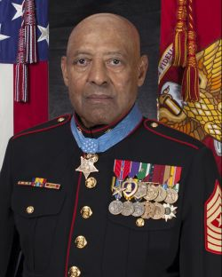

“On 31 January, when his company came under a heavy volume of enemy fire near the city of Hue, Gunnery Sergeant Canley rushed across the fire-swept terrain and carried several wounded Marines to safety. Later, with the company commander seriously wounded, Gunnery Sergeant Canley assumed command and immediately reorganized his scattered Marines, moving from one group to another to advise and encourage his men. Although sustaining shrapnel wounds during this period, he nonetheless established a base of fire which subsequently allowed the company to break through the enemy strongpoint.”
Metal of Honor recipients are like our first responders who rush towards danger while everyone is running away. Brothers and Sisters, Jesus Christ is our divine Metal of Honor recipient. Unlike the 3522 American soldiers who have received the United States Metal of Honor there is only one recipient of the heavenly Metal of Honor, Jesus Christ. Jesus Christ is our mighty God, our hero, who rescues us from attack.

Let me tell you His amazing story.

As we travel across this earthly terrain we came under attack from a fierce enemy that sought to steal, kill, and destroy. (Jn.10.10) The enemy’s assault against us was with flaming missiles, seeking to devour us like a roaring lion, and to sift us like wheat. (Eph.6.16; IPt.5.8; Lk.22.31) We laid on the battlefield of life bruised, broken, and beaten. The Lord Jesus Christ rushed in and single handedly disarmed the rulers and authorities and put them to open shame, by triumphing over them by the cross. (Col.2.15) Although He suffered multiple wounds during this period nonetheless He established a secure base for His people to fight against the forces of evil and guarantee their eventual victory. (Is.53.5; Eph.6.11; Rev.11.15)

The child that is born and the Son that is given is our Mighty God. Let’s trust Him for the forgiveness of our sins, to heal our diseases, and to govern the affairs of our lives with the authority of the Most High!

Call to Prayer
Finally, be strong in the Lord and in the strength of His might. (Eph.6.10)

Benediction
Now to Him who is able to keep you from stumbling, and to make you stand in the presence of His glory blameless with great joy, to the only God our Savior, through Jesus Christ our Lord, be glory, majesty, dominion and authority, before all time and now and forever. Amen. (Jd.1.24-25)

