Believers in Babylon Series
“A Eulogy for Daniel”
Daniel 12.13

Preaching Prelude

Today we come to the last sermon in our series entitled “Believers in Babylon.” For the past ten weeks we’ve been looking at the book of Daniel and how God enabled Daniel to live for the glory of God as an exile in a strange land.

This morning’s sermon will be “A Eulogy for Daniel” as we consider his life, his dreams, and the example he has been for centuries. As we prepare our hearts for worship I think it would be fitting for us to recite together Psalms 23, a Psalm I’m sure Daniel recited many times in his life.

As the ushers come forward and we prepare to give the Lord His tithes along with our offering and alms, let stand together and recite Psalm 23.

Call to Worship

The Lord is my shepherd, I shall not want.
² He makes me lie down in green pastures; He leads me beside quiet waters.
³ He restores my soul;
He guides me in the paths of righteousness for His name’s sake.
⁴ Even though I walk through the valley of the shadow of death,
I fear no evil, for You are with me; Your rod and Your staff, they comfort me.
⁵ You prepare a table before me in the presence of my enemies;
You have anointed my head with oil; My cup overflows.
⁶ Surely goodness and lovingkindness will follow me all the days of my life,
And I will dwell in the house of the Lord forever. Psalm 23 NASB

Introduction

For the past ten weeks we have been looking at the book of Daniel as a divine manual giving us instruction as to how to live as exiles in this world, our Babylon. When you get to the end of the book of Daniel, Daniel is an elder statesman in his late eighties. He has faithfully lived for the Lord his entire life, received dreams and visions that can only be compared to the Apostle John, and has given us an example of how to live for the glory of God in a fallen world.

The last verse of the last chapter the Lord tells Daniel through a divine messenger, “But as for you, go your way to the end; then you will enter into rest and rise again for your allotted portion at the end of the age.” (12.13) This verse summarizes what we all would like to hear at the end of our lives. Go your way, enter into rest, rise again, and receive your eternal inheritance in Christ.
For the past ten weeks we have looked at one chapter a week and you might be wondering what happened to chapter ten, eleven, and twelve. The last three chapters of the book of Daniel is Daniel’s last dream before his death. The last three chapters is Daniel’s forth and final dream that gives extensive details behind the revelations that Daniel had already received in earlier dreams. Due to the fact that this final dream is three chapters long and covers material similar to Daniel’s previous dreams I thought it would be more edifying to conclude this series by giving a eulogy for Daniel.

A Eulogy for Daniel

I’ve entitled this sermon “A Eulogy for Daniel.” As a pastor, I have officiated many funeral services. Usually at the beginning of the service someone reads the eulogy, which normally consists of the person’s date of the birth, the date of their passing away, and mentioning the members of their immediate family. But a eulogy is actually more than that. A eulogy is a speech or writing in praise of a person, especially a deceased person. And in this sermon I want to praise God for Daniel as we remember his life, his dreams, and the example he has left us.

Daniel’s Life

Let’s take a look at Daniel’s life. We were first introduced to Daniel when he along with other young Jewish boys were taken captive by Nebuchadnezzar, the king of Babylonian Empire, to be trained as a skilled government official. These young boys had no defects, were good-looking, had intelligence in every branch of wisdom, were endowed with knowledge and discernment, and were chosen to be trained to serve in Nebuchadnezzar’s golden Babylonian empire. (1.3-5)

Daniel and his friends said, “yes,” to a pagan education. They said, “yes,” to a political career in the service to a foreign king and government that stood in direct contraction to their own religious, political and national beliefs. They said, “yes,” to the changing of their biblical to names to names that honored pagan gods. They made a commitment to seek the welfare of the city believing that God had sent them there. They would pray for the city and seek for its welfare through their individual contributions to society. (Jer.29) But they would say, “no,” to eating the king’s food. Daniel resolved not to defile himself with the royal food and wine, and he asked the chief official for permission not to defile himself this way. (1.8) At a very young age Daniel resolved that even though he had been taken away from his family, his country, his Temple nothing was going to take him away from his covenant love for the Lord of Host! Having this type fervent love for God is essential to live for the glory of God in this world. This is a key point in living as exiles in a foreign land. You can take everything I have, everything I am, all my dreams, and all my hopes, but you cannot have my love and devotion to God as my Lord, my Savior, my Redeemer, my Provider.

Daniel and his three friends Shadrach, Meshach, and Abednego were promoted to the highest levels of government in Babylon (2.48-49) but it wouldn’t be long until their unwavering faith would be tested. Years later Nebuchadnezzar would construct a massive golden statue and demand everyone in the empire to bow to it.

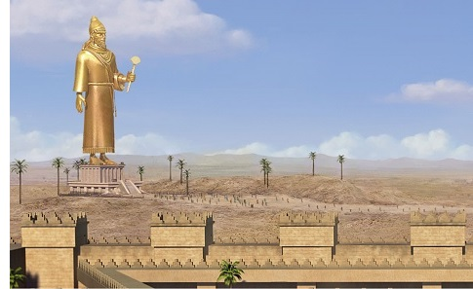

Daniel’s friends knew that Nebuchadnezzar’s edict was in direct conflict with their covenant commitment with God and they would not bow. As a result Nebuchadnezzar ordered them to be burned alive in a fiery furnace. As they were thrown into the furnace One like the Son of God appeared and protected them from the flames so that not even the smell of smoke was on their garments. (3.1-30)

Nebuchadnezzar responded and said, “Blessed be the God of Shadrach, Meshach and Abed-nego, who has sent His angel and delivered His servants who put their trust in Him, violating the king’s command, and yielded up their bodies so as not to serve or worship any god except their own God. (3.28)

Daniel and his three friends faithfully served in the foreign government of Babylon but their alliance was to the King of kings. They lived in Babylon but they were looking for a city whose architect and builder is God. They knew that this world was not their home.

Years later the Lord revealed to Daniel that the Persians would overthrow the Babylonians. The handwriting was on the wall that the Persian invasion was just outside the city gates. (5.1-31) The Persians conquered the Babylonian Empire. Daniel not only survived the violent takeover but he once again rose to the highest level of governmental power.

Daniel is now in his eighties. He had served faithfully for over seventy years and once again Daniel’s covenant love for God would be tested but this time it would come through the decree of Darius, the Persian overseer of Babylonian territory. In an attempt to gain control of the territory of Babylon, Darius decreed that if anyone prays to any god or human for thirty days, except to Darius himself, that person would be thrown into the loins’ den.

Now when Daniel learned that the decree had been published, he went home to his upstairs room where the windows opened toward Jerusalem. Three times a day he got down on his knees and prayed, giving thanks to his God, just as he had done before. (6.10)
Daniel’s actions were not out of defiance to Darius or his decree. His actions were simply out of a heart of love and devotion to God. Daniel believed that no-one and no-thing was going to come in-between him and God. And this is what Darius’ decree had done. This type of spiritual devotion is key for a believer’s survival in this world.

Daniel’s actions were reported to Darius and he was forced by his own decree to throw Daniel into the lion’s den. But just as the flames of the furnace were not able to bring the smell of smoke upon the clothes of Daniel’s friends so the loins were not permitted to touch Daniel.

Then Darius the king wrote to all the peoples, nations and men of every language who were living in all the land: “May your peace abound! I make a decree that in all the dominion of my kingdom men are to fear and tremble before the God of Daniel; For He is the living God and enduring forever, And His kingdom is one which will not be destroyed, And His dominion will be forever. “He delivers and rescues and performs signs and wonders in heaven and on earth, Who has also delivered Daniel from the power of the lions.” So this Daniel enjoyed success in the reign of Darius and in the reign of Cyrus the Persian. (6.25-28)

Wow! What a life! Daniel would die a few years later with the confidence of knowing that he had served both God and man faithfully throughout his whole life. Knowing that you lived your life with uncompromised faith to the glory of God this is life’s greatest achievement . Daniel could say like the Apostle Paul,

I have fought the good fight, I have finished the race, I have kept the faith. Now there is in store for me the crown of righteousness, which the Lord, the righteous Judge, will award to me on that day—and not only to me, but also to all who have longed for his appearing. (2Tim.4.7-8)

Daniel’s Dreams

Daniel not only lived a distinguish life but God had gifted him with the extraordinary ability to interpret dreams and receive divine revelations. As a young man God enabled Daniel to interpret Nebuchadnezzar’s dream. (2.1-49) Nebuchadnezzar’s dream would lay the foundation for Daniel’s understanding of future events that would lead up to the second coming of Christ and the establishment of God’s eternal kingdom. Later in Daniel’s life, in his old age, God would give Daniel additional dreams that disclosed details behind what he saw in this first revelation. But at this point as a young man this dream is all that Daniel knew. But it was this dream given to Daniel in his earlier years that laid the foundation for him to know that God would orchestrate world history to bring forth the Messiah and establish His eternal kingdom.

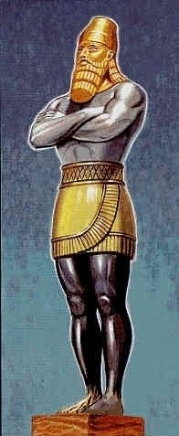

Daniel tells Nebuchadnezzar that in his dream he saw was a great statue, which was large and of extraordinary splendor, and its appearance was awesome. The head of the statue was made of fine gold, its breast and its arms of silver, its belly and its thighs of bronze, its legs of iron, it’s feet partly of iron and partly of clay. (2.31-33) At this time Daniel could only identify the head of gold as the Babylonian Empire but decades later through a series of four dreams the Lord would reveal the details of the other empires that would emerge on the world stage. (ch. 7, 8, 9, 10-12)

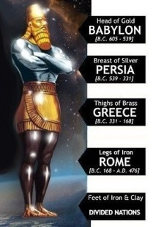

Later in Daniel’s life God revealed to Daniel that after Babylon the Persian Empire would emerge on the world stage, after Persia then Greece, after Greece then Rome, and after Rome the Divided Nations. Of course, we know that Jesus’ life, death, and resurrection occurred during the rule of the Roman Empire. So, Daniel’s dreams tell us the four empires leading up to Jesus’ first coming. And the dream also tells us that after the fulfillment of God’s redemption through Jesus Christ on the cross these Divided Nations will occupy the world stage. Later in Daniel’s life, God revealed to Daniel that these nations would wage war against one another and bring great harm to the people of God. Each time the Lord revealed this persecution against God’s people Daniel would become emotionally overwhelmed and physically distressed. (7.21; 8.27; 12.8)

The age of the Divided Nations is the age we live in right now. And because we live in the time of the Divided Nations many Christians are obsessed with trying to identify what nations are represented in these clay feet and those ten toes. This obsession has created a variety of different views and has caused a lot of confusion surrounding the Daniel’s dreams. (7-12) The obsession of trying to precisely identify what nation is represented by each toe has caused many to miss the main point of Nebuchadnezzar’s dream and the main point of the dreams Daniel will have later in his life.

And let me mention the main point of Daniel’s dreams so that you don’t miss it. The main point of all of Daniel’s dreams is that no matter how messed up the world is – God is still in control and He is orchestrating world history to establish His eternal Kingdom through Christ. If there is anything I have discovered in all my years of studying biblical prophesy it is this – if the details of your interpretation have taken you down a road that hinders the glory of God and the establishment of His eternal Kingdom through Christ then you have taken a wrong turn. If something else like the millennium, or the tribulation, or the number of years have become more important than Christ then you are watching the wrong movie. If someone else like the antichrist, or the Beast, or some world ruler has become the primary figures instead of Christ then you are watching the wrong channel. It is about Christ. It has always been about Christ.

You see, Daniel’s explanation of Nebuchadnezzar’s dream doesn’t end with the nations of this world standing in defiance to God.

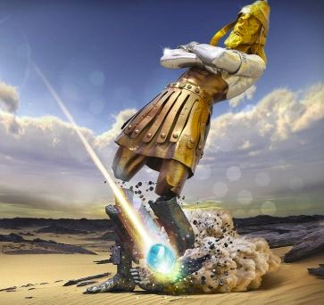

Daniel tells Nebuchadnezzar that as he continued to look upon this great single statue, a stone cut out of the mountain without hands strikes those clay feet and ten toes like a meteor out of heaven causing the statue to collapse into a pile of rubble. After the dust settles not a trace was found of the great empires of world history and the divided nations. This Messianic Meteor coming down out of heaven is the second coming of Christ.

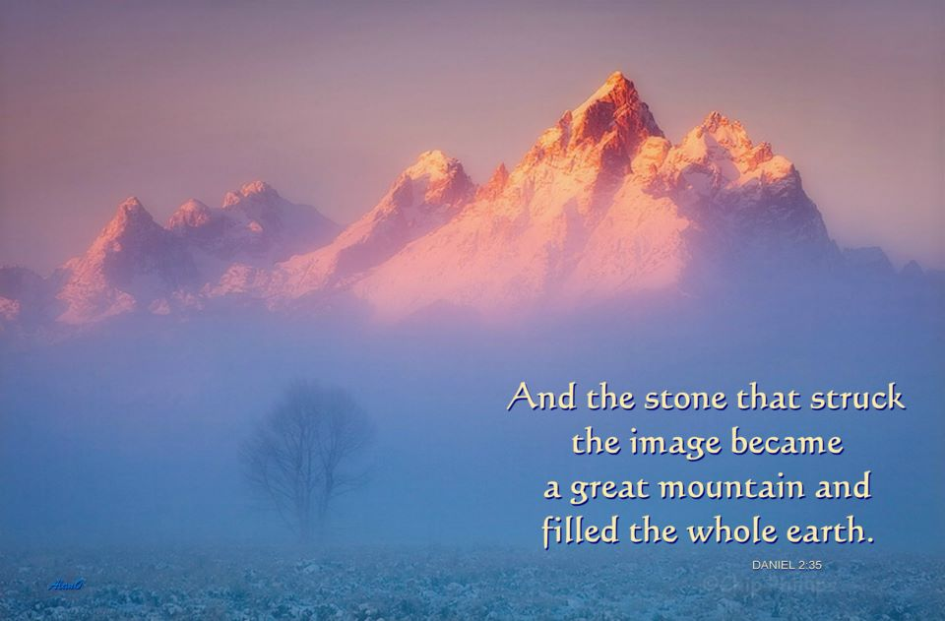

Daniel explains that the stone that struck the statue becomes a great mountain that fills the whole earth. This is the established of the Kingdom of Christ at Christ’s second coming when the kingdom of this world become the Kingdom of our Lord and of His Christ and He will reign forever and ever! (Rev.11.15) This is the established of the Kingdom of Christ at Christ’s second coming when this earth passes away and the Lord creates a new heaven and a new earth. (Rev.21.1)

Daniel’s dreams have always been about Christ’s rule and reign. In Daniel’s first dream the Lord Jesus is introduce as the “stone made without hands.” (2.34-35, 44-45) In chapter seven the Lord Jesus is presented as the “One like the Son of Man” who is “given dominion, glory, and a kingdom.” (7.13-14) In chapter eight the Lord Jesus is the “Prince of princes” who will destroy the wicked one with divine justice. (8.25b) In chapter nine the Lord Jesus is the “Messiah” who will usher in the perfect Jubilee. (9.24) In chapter ten we see the Lord Jesus in His splendor and glory, as He will appear at His second coming. (10.5-6) In Daniel’s dream you have a variety morphed mystical creatures, animals, and all sorts of horns. But the one constant figure in all Daniel’s dreams is Christ. Christ is the centerpiece of prophecy and the goal of history. It’s all about Christ! The Sunday School student is correct the right answer is always Jesus!

Throughout the book Daniel presents a perfect eschatology that is consistent with the rest of Scripture. God reveals through Daniel that until second coming of Christ there will be a progression of wickedness in this world that will increase more and more as time passes. Even though the period before the Lord returns will be extremely difficult believers should have confidence that our God reigns on high, Christ will emerge the Victor, and one day He will give us an everlasting kingdom as an inheritance of grace.

This is the reason the Lord tells Daniel in the last verse of the last chapter, “But as for you, go your way to the end; then you will enter into rest and rise again for your allotted portion at the end of the age.” (12.13) These are the Lord’s final words to Daniel.

Daniel’s Final Word

What a fitting way for this hero of faith to conclude his book. “But as for you, go your way to the end; then you will enter into rest and rise again for your allotted portion at the end of the age.” (12.13) You talk about riding off into the sunset – this is it. And I think it is fitting for us to pour these final words into our own lives. For Daniel’s faith is our faith. He was a man just like you and me. And as for us, let’s follow Daniel’s example and live our lives to the glory of God as we live in this world. Let’s build a legacy of faith like Daniel so that it can be said of us that we fought the good fight, we finished the race, and we kept the faith. Let’s enter into the rest of Christ and stop laboring to make our selves acceptable to God by our own works and trust in the work of Christ. (Heb.4.9-10) Let us have faith believing that if we die before the Lord returns we will rise again and with Daniel receive our glorious inheritance of grace.
Let’s live our lives to hear the Lord say, “Well done, good and faithful servant. Come inherit the kingdom prepared for you from the foundation of the world.” (Mt.25.21, 34)

Call to Prayer

Maranatha (ICor.1.22b)

This short prayer means, “come, O Lord” or “the Lord is coming.” Christians in the early church commonly used it. Maranatha reminds us to keep our eyes on the eternal things of the Spirit. Looking down, we see the earth; looking around, we see earthly things. But looking up, we see the hope of the soon coming of our Lord Jesus Christ. To those who are discouraged today, Maranatha! To those who are worried today, Maranatha! To those who are filled with anxiety over the problems you are facing, Maranatha! Our Lord is coming!

Benediction

To the only wise God, through Jesus Christ, be the glory forever. Amen. (Rom.16.27)

