Colossians – Keeping Christ in Focus Series
“In Christ at Colossae”
Colossians 1.1-14

Introduction

Today I’m beginning a nine-part series on the book of Colossians. Colossians is a special book. 4 chapters, 95 verses, and about half of those verses reference Jesus. And 15 times you see the phrase, “in Christ”, or similar, so in Colossians we get a clear idea of how Jesus should affect our lives. And over and over again you see we should be rooted, established, mature, and complete in Christ.

Out text today is Colossians chapter one, verses one through fourteen. Hear now the Word of God.

Paul, an apostle of Jesus Christ by the will of God, and Timothy our brother, ² To the saints and faithful brethren in Christ who are at Colossae: Grace to you and peace from God our Father. ³ We give thanks to God, the Father of our Lord Jesus Christ, praying always for you, ⁴ since we heard of your faith in Christ Jesus and the love which you have for all the saints; ⁵ because of the hope laid up for you in heaven, of which you previously heard in the word of truth, the gospel ⁶ which has come to you, just as in all the world also it is constantly bearing fruit and increasing, even as it has been doing in you also since the day you heard of it and understood the grace of God in truth; ⁷ just as you learned it from Epaphras, our beloved fellow bond-servant, who is a faithful servant of Christ on our behalf, ⁸ and he also informed us of your love in the Spirit. ⁹ For this reason also, since the day we heard of it, we have not ceased to pray for you and to ask that you may be filled with the knowledge of His will in all spiritual wisdom and understanding, ¹⁰ so that you will walk in a manner worthy of the Lord, to please Him in all respects, bearing fruit in every good work and increasing in the knowledge of God; ¹¹ strengthened with all power, according to His glorious might, for the attaining of all steadfastness and patience; joyously ¹² giving thanks to the Father, who has qualified us to share in the inheritance of the saints in Light. ¹³ For He rescued us from the domain of darkness, and transferred us to the kingdom of His beloved Son, ¹⁴ in whom we have redemption, the forgiveness of sins.

Colossians is one of the letters written by the Apostle Paul to various churches in the Roman Empire. It is called a Prison Epistle because the Apostle Paul wrote it while he was in prison in Rome for proclaiming the Gospel of Jesus Christ. One of the unique factors about this letter is that even though the Apostle Paul might have travel through Colossae during his third missionary journey on his way to Ephesus, he did not do any ministry in the city of Colossae or plant this church. Paul’s ministry during his third missionary journey was to strengthen the churches he had already planted and to return to Ephesus where he only had a brief visit year’s before. (Acts 18.19-21)

The City of Colossae
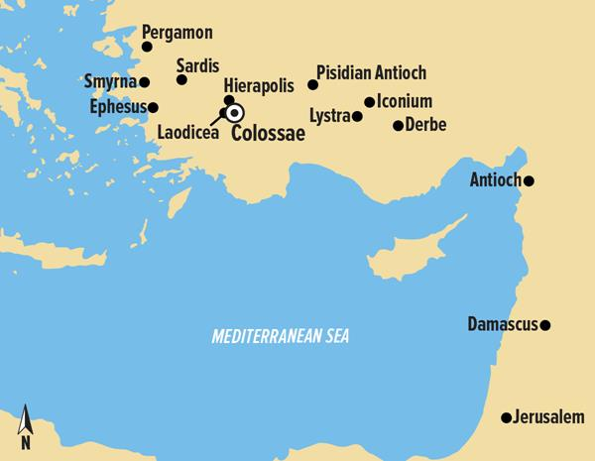

Colossae, Hierapolis, and Laodicea were the three leading cities in the Lycus Valley. Hierapolis is mentioned in chapter four and Laodicea is mentioned four times in Colossians and in the book of Revelation. (Col.4.13; 2.1, 13, 15, 16; Rev.3.14-22) These sister cities shared a lot in common mostly because of their importance to the wool industry. By the time that Paul wrote to Colossae the city had become the least influential of the three.

Epaphras

As I mentioned the Apostle Paul did not plant the church of Colossae. Epaphras was probably the founder of the church, who had been converted through the ministry of Paul, most likely in Ephesus. Paul writes that the Colossians had learned the word of truth, the gospel and the grace of God in truth from Epaphras. (1.5, 6-7) Thank God for faithful ministers of the Gospel, like Epaphras, who work diligently to bring the Word of God to the people of God. Who did the Lord used to share the Gospel with you? Paul heaps praise upon Epaphras calling him a beloved fellow bond-servant and a faithful servant of Christ. (1.7) Epaphras must had bee humbly encouraged to have his good friend and fellow bond-servant in Christ say these wonderful word about him. Maybe you should reach out to the individual(s) that the Lord to minister the Gospel to you. Epaphras was native Colossian and a hard worker for the Gospel in the three congregations in the Lycus Valley. (4.12)

Epaphras visited Paul in prison, bringing him news of the Colossians progress in the faith. Paul writes in verse four Paul that Epaphras had told Paul about the Colossian’s faith in Christ Jesus and the love which you have for all the saints. (1.4) And he had informed Paul about their love in the Spirit. (1.7) But four years prior the Apostle Paul had warned the elders of the nearby congregation in Ephesus that savage wolves will come in among you, not sparing the flock; and from among your own selves men will arise, speaking perverse things, to draw away the disciples after them. (Acts 20.29-30) Judging from Paul’s letter to the Colossians Paul’s prophecy was fulfilled as the wolves appeared in the little city of Colossae. It seems that Epaphras not only brought Paul news about the Colossian’s progress in the faith but had also brought him news of these false teachers that were speaking perverse things to draw disciples after them. We will talk more about the Colossian heresy in weeks to come but for now let’s just say that these false teachers were seeking to draw the Colossian Christian’s focus off of Christ. So, Paul through the inspiration of the Holy Spirit will write his epistle calling those in Christ at Colossae to keep their focus on Christ.
In Christ at Colossae

Paul will address this heresy head-on later in the book but for now he wants to remind the Colossians of who they are in Christ. (1.2) He wants to thank God for what He has done at Colossae. (1.3-8) And he wants to pray for what God will do in the future. (1.9-12) So often when we face problems we get lost in the fog. During times of confusion we get our eyes off of Christ. Our conflicts often distract us from giving thanks for what God has done. So often the controversy causes us to lose our focus on what God can do. So Paul is going to take the first fourteen verses to get the Colossians focused on Christ. Focused on who they are in Christ. Focused on what God has done in their lives. And focused on what God will do in the future!

Focused On Who We Are In Christ

In Paul’s greeting he reminds the Colossians that they are saints and faithful brethren in Christ who are at Colossae. (1.2) This is a common greeting for the Apostle to use in his epistles but it should not be overlooked just because it was common. The Christians at Colossae were saints in Christ, brethren in Christ. The Apostle loved to called Christians saints, literally “holy ones,” but notice he says, “saints in Christ.” In ourselves we are not holy but in Christ we are holy. By God’s grace we have been set apart from the world and placed in Christ. All the accomplishments of Christ are ours because we are in Christ! Every spiritual blessing in the heavenly places is our in Christ! (Eph.1.3) We receive grace in Christ. (ICor.1.4) Our redemption is in Christ. (Rom.3.24) We are justified in Christ. (Gal.2.17) We have forgiveness of sins in Christ. (Eph.4.32) There is no condemnation in Christ. (Rom.8.1) We are a new creation in Christ. (2Cor.5.17) We have eternal life in Christ. (Rom.6.23) God supplies all of our needs in Christ. (Phil.4.19) We will be presented to God perfect on Christ. (Col.1.28) We cannot be separated from the love of God in Christ. (Rom.8.32) Yes! God has willed to make known to us the riches of His glory, . . . which is Christ in you, the hope of glory. (Col.1.27)

Focused On What God Has Done In Our Lives

After reminding the Colossians that they are in Christ, the Apostle focuses on what God has done in their lives. Being placed in Christ is a definite work of God’s grace but after that the Christian’s life is a journey of sanctification in which God’s grace conforms us more and more in the image of Christ. Paul wants to remind the Christians at Colossae how far they have already traveled by the power of the Holy Spirit. He will give two examples of the progressive work of the Holy Spirit by showing what God had done in the lives of the Colossian believers.

In the first example Paul mentions three things that God had done in the lives of the Colossians. He writes, we heard of your faith in Christ Jesus and the love which you have for all the saints; because of the hope laid up for you in heaven. (1.4-5a)

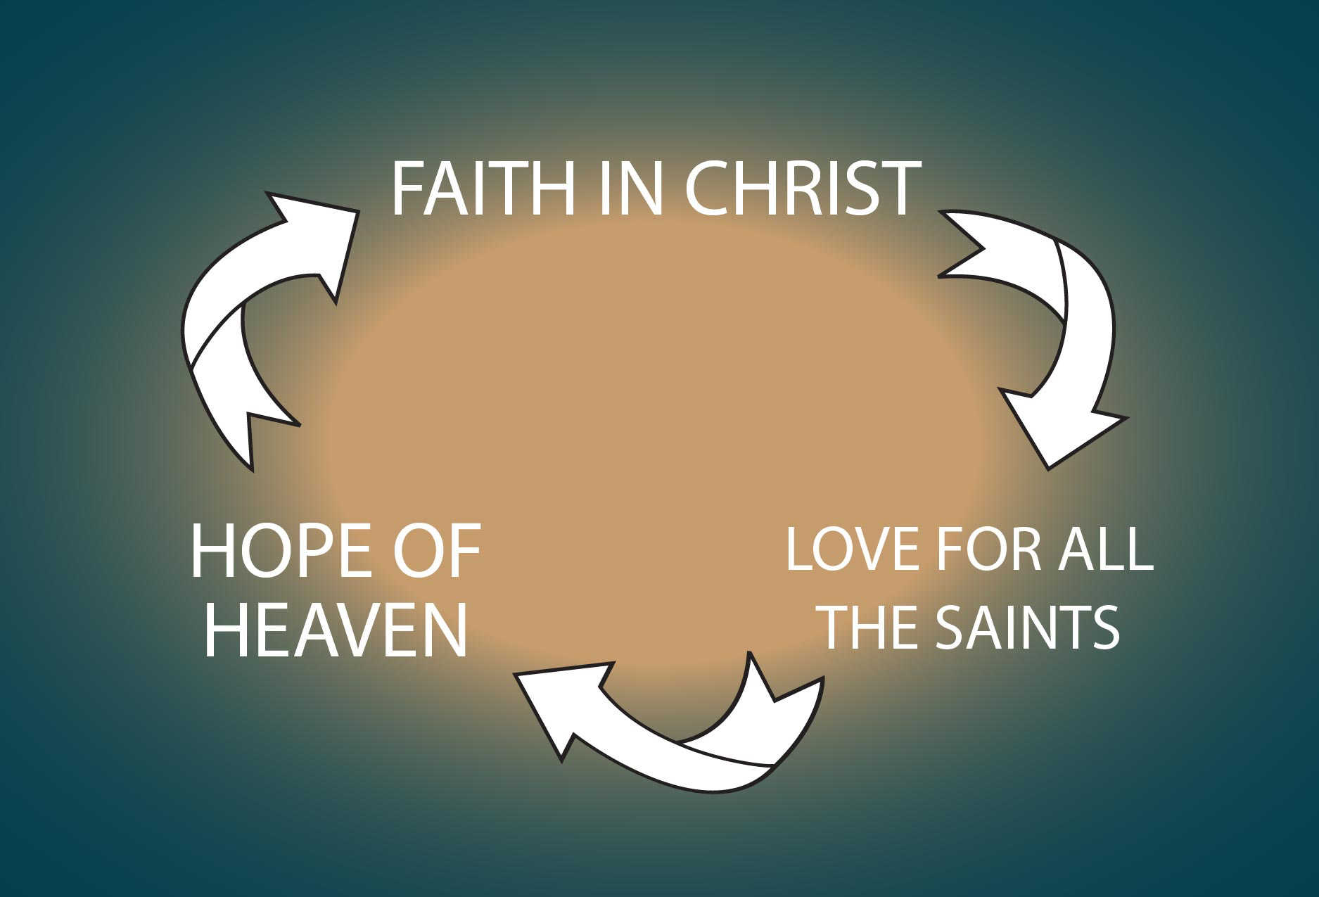

This faith in Christ is not just referring to saving faith but also the sanctifying faith in Christ (Acts 28.16) that enables the believer to grow in their abiding trust in Jesus Christ. As a new believer we might have faith in Christ like a child but as we walk in Christ our faith becomes more mature and we grow in our confidence in Christ.

Our faith in Christ drives us to have love for all the saints. Our faith in Christ has brought us together as the family of God where we grow in love for all of God’s people without prejudice or distinction. As Paul will tells us in chapter three, there is no distinction between Greek and Jew, circumcised and uncircumcised, barbarian, Scythian, slave and freeman, but Christ is all, and in all. So, as those who have been chosen of God, holy and beloved, put on a heart of compassion, kindness, humility, gentleness and patience; bearing with one another, and forgiving each other, whoever has a complaint against anyone; just as the Lord forgave you, so also should you. (Col.3.11-13)

Our faith in Christ and our love for all the saints drives us deeper in our hope of heaven. Have you heard the phrase “so heavenly minded not earthly purpose?” Well, Paul is throwing that idea right out of the window. Paul is saying that as a Christians progresses in their walk in Christ they will naturally develop a deep assurance in the promises of God not only in this life but also in the life to come. As a Christian matures they begin to put less confidence in the treasures of the life and seek to lay up treasures in heaven, where neither moth nor rust destroys, and where thieves do not break in or steal. (Mt.6.20) The Christian grows in confidence that Christ has promised an inheritance, which is imperishable and undefiled and will not fade away, reserved in heaven for you. (IPt.1.4)

This progressive work of the Holy Spirit causes the believer to grow in their faith in Christ, their love for all the saints, and their hope of heaven more and more as they walk in the Spirit.

Focused On What God Has Done In Our Lives

The second example of what God had done in the lives of the Colossians is similar to the first. Paul writes, . . . of which you previously heard in the word of truth, the gospel which has come to you . . . constantly bearing fruit and increasing . . . he also informed us of your love in the Spirit. (1.5-8)
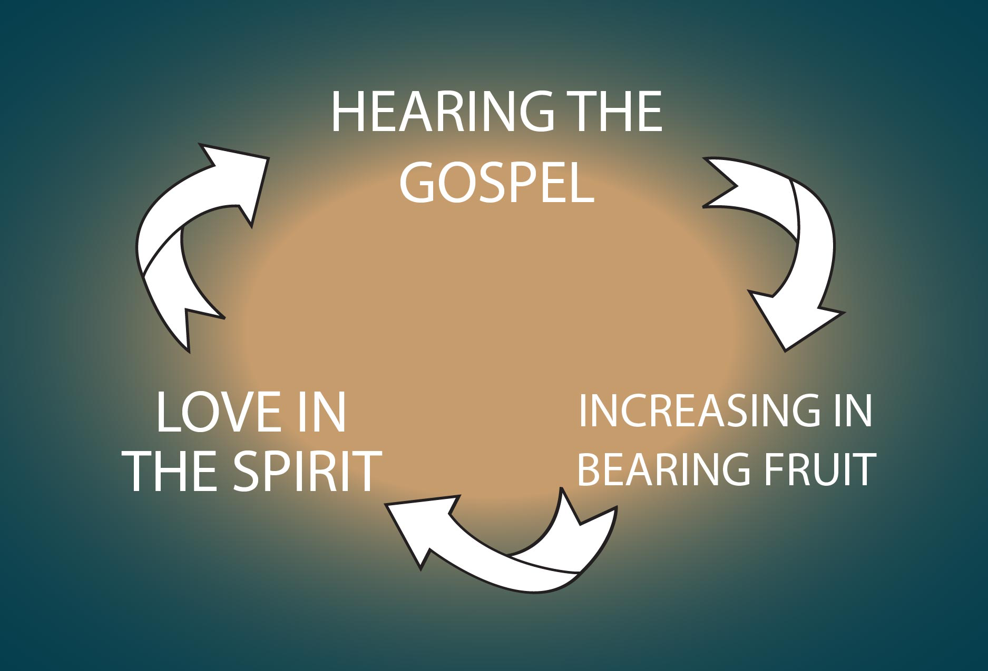

Paul reminds them that the Spirit had open their deaf ears to hear the gospel, that the Spirit was constantly and increasing bearing fruit in their lives, and their love in the Spirit had grown more and more since the day they had heard and understood the grace of God in truth.

This progressive work of the Holy Spirit is the normal way the Spirit works in the life of the believer and we should all take time to reflect on what God has done in our lives and thank Him for the growth He has allowed us to experience.

Paul writes in verse nine, “For this reason.” Since God has done such an amazing work in the lives of the Colossian Christians Paul now wants to focus on what God will do for the church at Colossae in the future and pray for them with holy expectation. (1.9-12a)

Focused On What God Will Do

Paul will offer four clear prayer requests to God on behalf of the Colossians. He will pray that God will fill them with the knowledge of His will. Secondly, he will pray that God would enable them to they walk in a manner worthily of the Lord. Thirdly, that they would bear fruit in every good work. And lastly, he will pray that God will strengthen them with all power, according to His glorious might. It seems to me that Paul had great expectation that God was going to do great things in the church of Colossae. Let’s quickly look at these powerful petitions.

First, Paul prays that God will fill them with the knowledge of His will. He writes, we have not ceased to pray for you and to ask that you may be filled with the knowledge of His will in all spiritual wisdom and understanding. (1.9) Paul is not praying that they would be filled with worldly philosophy or empty deception. (2.8) On the contrary, Paul was praying that they would be filled with God’s wonderful, redemptive revelation of Jesus Christ, in whom are hidden all the treasures of wisdom and knowledge. (2.3) Paul was praying that God would give them the ability to discernment between the wisdom of this world and God’s wisdom found in Christ. As James tells us, the wisdom from above is first pure, then peaceable, gentle, reasonable, full of mercy and good fruits, unwavering, without hypocrisy. (Js.3.17)

That leads us to Paul’s second request that God would enable them to they walk in a manner worthily of the Lord. Paul writes, so that you will walk in a manner worthy of the Lord, to please Him in all respects. (1.10a) Notice the “so that.” This is the great purpose clause of the New Testament. What Paul is saying is that the fullness of the knowledge of God’s will should lead the believer to walk in a manner worthy of the Lord and should cause the believer to desire to please the Lord in every aspect of life. Whether, then, you eat or drink or whatever you do, do all to the glory of God. (ICor.10.31)

This God glorifying lifestyle should lead to the bearing fruit in every good work and increasing in the knowledge of God. (1.10b) This is the spiritual sequence. Praying for spiritual wisdom, leads to walking worthy of the Lord, which leads to bearing fruit in every good work.

And lastly Paul prays that God will strengthen them with all power, according to His glorious might. Notice that the purpose for attaining this spiritual power is not to be God’s wrecking ball but rather it is for the attaining of all steadfastness and patience; joyously giving thanks to the Father. Paul writes, strengthened with all power, according to His glorious might, for the attaining of all steadfastness and patience; joyously giving thanks to the Father. (1.11-12a) Paul is praying that they would be strengthen with power through the Spirit in the inner man; so that Christ would dwell in their hearts through faith as they encounter difficulties and controversies.

Paul’s prayer for the Colossae Church should be our prayer for Christ Covenant Church. We should ask that God would fill us with the knowledge of His will, that God would enable us to walk in a manner worthily of the Lord, that we would bear fruit in every good work, and that God will strengthen us with all power, according to His glorious might as we encounter difficulties and controversies. We should share in Paul’s expectation that God was going to do great things in this church.

Closing Thoughts

Paul had great optimism for the church at Colossae because he knew that because they were in Christ god had qualified them to share in the inheritance of the saints. He knew that God had rescued them from the domain of darkness, and transferred them to the kingdom of His beloved Son, in whom they have redemption, the forgiveness of sins.

So as I close today let me ask you, “Are you in Christ?” Is God drawing you to receive the grace and forgiveness offered in His Son, Jesus Christ?

I want to challenge you each to take time to reflect on what God has done in your life and thank Him for the growth He has allowed you to experience.

I want to ask you to pray for Christ Covenant Church that God will fill us with the knowledge of His will, to enable us to walk in a manner worthily of the Lord, that we would bear fruit in every good work, and that God will strengthen us with all power, according to His glorious might as we encounter difficulties and controversies.

I want you to ask that Holy Spirit to give us a sense of divine expectation of the great things God is going to do in and through this church as He did for those in Christ at Colossae.

Call to Prayer
And Your godly ones shall bless You.
They shall speak of the glory of Your kingdom
And talk of Your power; (Ps.145.10b-11)

