Colossians – Keeping Christ in Focus Series
“The Supremacy of Christ”
Colossians 1.15-23

Introduction

Last week we began a new series on the book of Colossians. The city of Colossae is located in modern day Turkey.

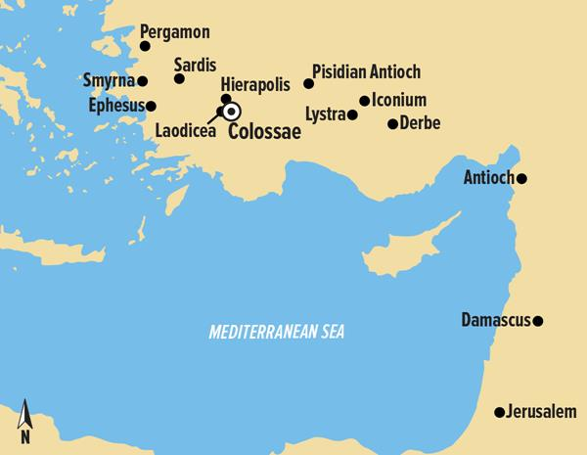

The Apostle Paul wrote to the Colossian Church after receiving a report about the church from its founder and fellow bondservant in Christ, Epaphras. (1.7) Epaphras brought Paul news about the Colossian’s progress in the faith and news about false teachers that were speaking perverse things in the church to draw disciples after them. These false teachers were seeking to draw the Colossian Christian’s focus off of Christ. So, Paul through the inspiration of the Holy Spirit writes his epistle calling those in Christ at Colossae to keep their focus on Christ.

After reminding the Colossians that they were in Christ, thanking God for what He had done in their lives, and praying for the Lord to continue to do great things in the church, the Apostle focuses on the first and primary problem these false teachers were teaching in the church. Basically, these false teachers were teaching that Christ was not enough for a person to enjoy the fullness of God. Christ wasn’t sufficient. These false teachers taught that a person needed mystic insights from angelic visions in order to receive the full knowledge of God.

The Apostle through the inspiration of the Holy Spirit will face these heretics head-on by exalting the supremacy of Christ. The Apostle will exalt Jesus Christ as the image of the invisible God, the creator and sustainer of the universe, and the head of His Church. He will destroy their empty deception by showing that as a result of the supremacy of Christ we have the fullness of God, the reconciliation of all things, and to enjoy the richness of the Gospel.

Some biblical scholars have labeled the book of Colossians as the “most Christ-centered book in the Bible” and the passage that we will look at today as the “most Christ-centered cluster of Scripture” found in the book. The Apostle will focus on Christ and on Christ alone. Today’s text will be Colossians chapter one verses fifteen through twenty-three. Hear now the Word of God.

¹⁵ The Son is the image of the invisible God, the firstborn over all creation. ¹⁶ For in Him all things were created: things in heaven and on earth, visible and invisible, whether thrones or powers or rulers or authorities; all things have been created through Him and for Him. ¹⁷ He is before all things, and in Him all things hold together. ¹⁸ And He is the head of the body, the church; He is the beginning and the firstborn from among the dead, so that in everything He might have the supremacy. ¹⁹ For God was pleased to have all His fullness dwell in Him, ²⁰ and through Him to reconcile to Himself all things, whether things on earth or things in heaven, by making peace through His blood, shed on the cross. ²¹ Once you were alienated from God and were enemies in your minds because of your evil behavior. ²² But now He has reconciled you by Christ’s physical body through death to present you holy in His sight, without blemish and free from accusation— ²³ if you continue in your faith, established and firm, and do not move from the hope held out in the gospel. This is the gospel that you heard and that has been proclaimed to every creature under heaven, and of which I, Paul, have become a servant.

The Supremacy of Christ

This passage of Scripture is all about the supremacy of Christ. The Apostle will first focus on the scope of Christ’s supremacy. (1.15-18) Then Apostle will focus on the result of Christ’s supremacy. (1.19-22) The Apostle is exhorting the Christians at Colossae to focus on Christ and not be taken captive by the elementary principles taught by these false teachers.

The Apostle declares three profound and sweeping statements concerning the scope of Christ’s supremacy. First, Christ is supreme because He is the image of the invisible God. Secondly, Christ is supreme because He is the creator and sustainer of the universe and everything in it. Lastly, Christ is supreme because He is the head of the Church.

Christ is the Image of the Invisible God

First, the Apostle makes the point that Christ is supreme because He is the image of the invisible God. The Apostle states it plainly, “The Son is the image of the invisible God.” (1.15a) Paul establishes first of all that Jesus Christ has always been, is, and always will be the complete and absolute representation of the invisible God to humanity. This is important because these false teachers were teaching that Jesus was not a complete Savior. So, the Apostle wants to establish that Christ is superior because He was and is God. The writer of Hebrews explains that the Son is the radiance of the Father’s glory and the exact representation of His nature. (Heb.1.3a) The Apostle John writes, “No one has seen God at any time; the only begotten God who is in the bosom of the Father, He has explained Him.” (Jn.1.18) The light of God’s glory is fully revealed in the face of Christ. (2Cor.4.6) Therefore, Christ is supreme because He is the image of the invisible God.

Christ is the Creator and Sustainer of the Universe

Secondly, the Apostle establishes that Christ is supreme because He is the creator and sustainer of the universe and everything in it. Paul writes, “The Son is . . . the firstborn over all creation. For in Him all things were created: things in heaven and on earth, visible and invisible, whether thrones or powers or rulers or authorities; all things have been created through Him and for Him. He is before all things, and in Him all things hold together.” (1.15b-17)

The Apostle declares that, “The Son is . . . the firstborn over all creation.” (1.15b) The emphasis here is that Christ has the supreme of rank and rule over every created thing. He is not part of creation. He reigns superior over all creation. To use the imaginary of a king, He has put all things are under His feet. Now in putting everything in subjection to Him, He left nothing outside His control. (Heb.2.8) Paul builds his case against these false teachers by stating, “For in (by) Him all things were created.”

Remember these false teachers taught that a person needed mystic insights from angelic visions in order to receive the full knowledge of God. So, Paul makes the point that Christ is superior to these angelic messengers because He created them. And Paul wants to make it clear that he means all things when he writes, “things in heaven and on earth, visible and invisible, whether thrones or powers or rulers or authorities; all things have been created through Him and for Him. He is before all things, and in Him all things hold together.” (1.16-17)

Here’s Paul theological logic:

Christ created all things.

And not just things in heaven and on earth
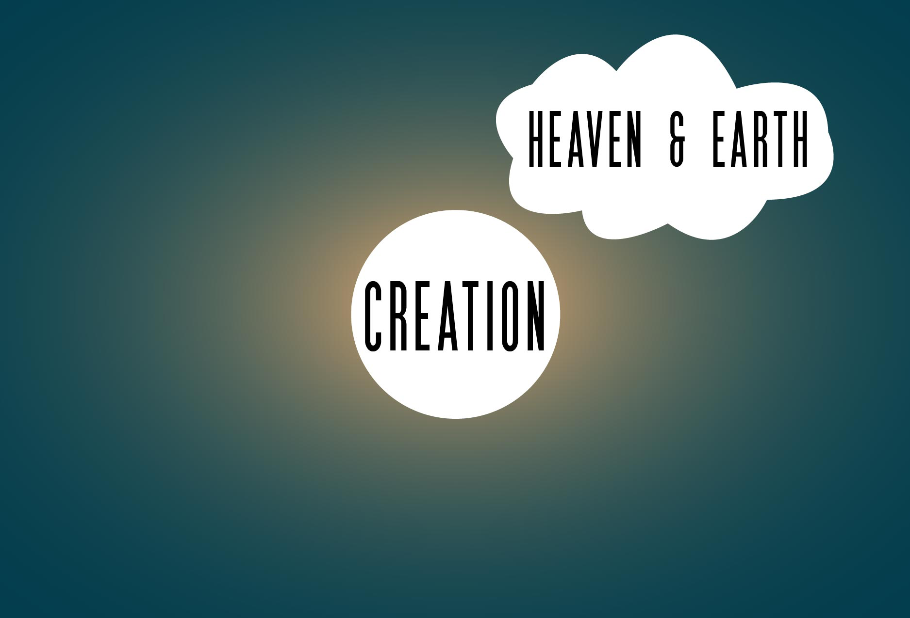

But things visible and invisible
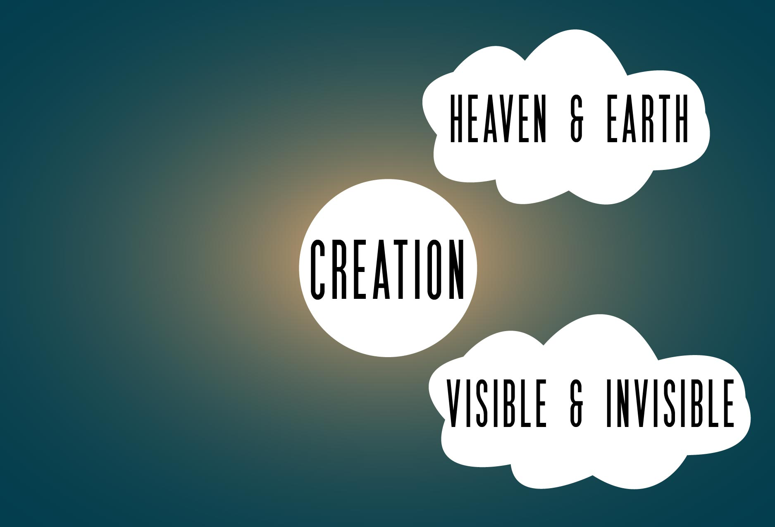

Whether thrones or powers
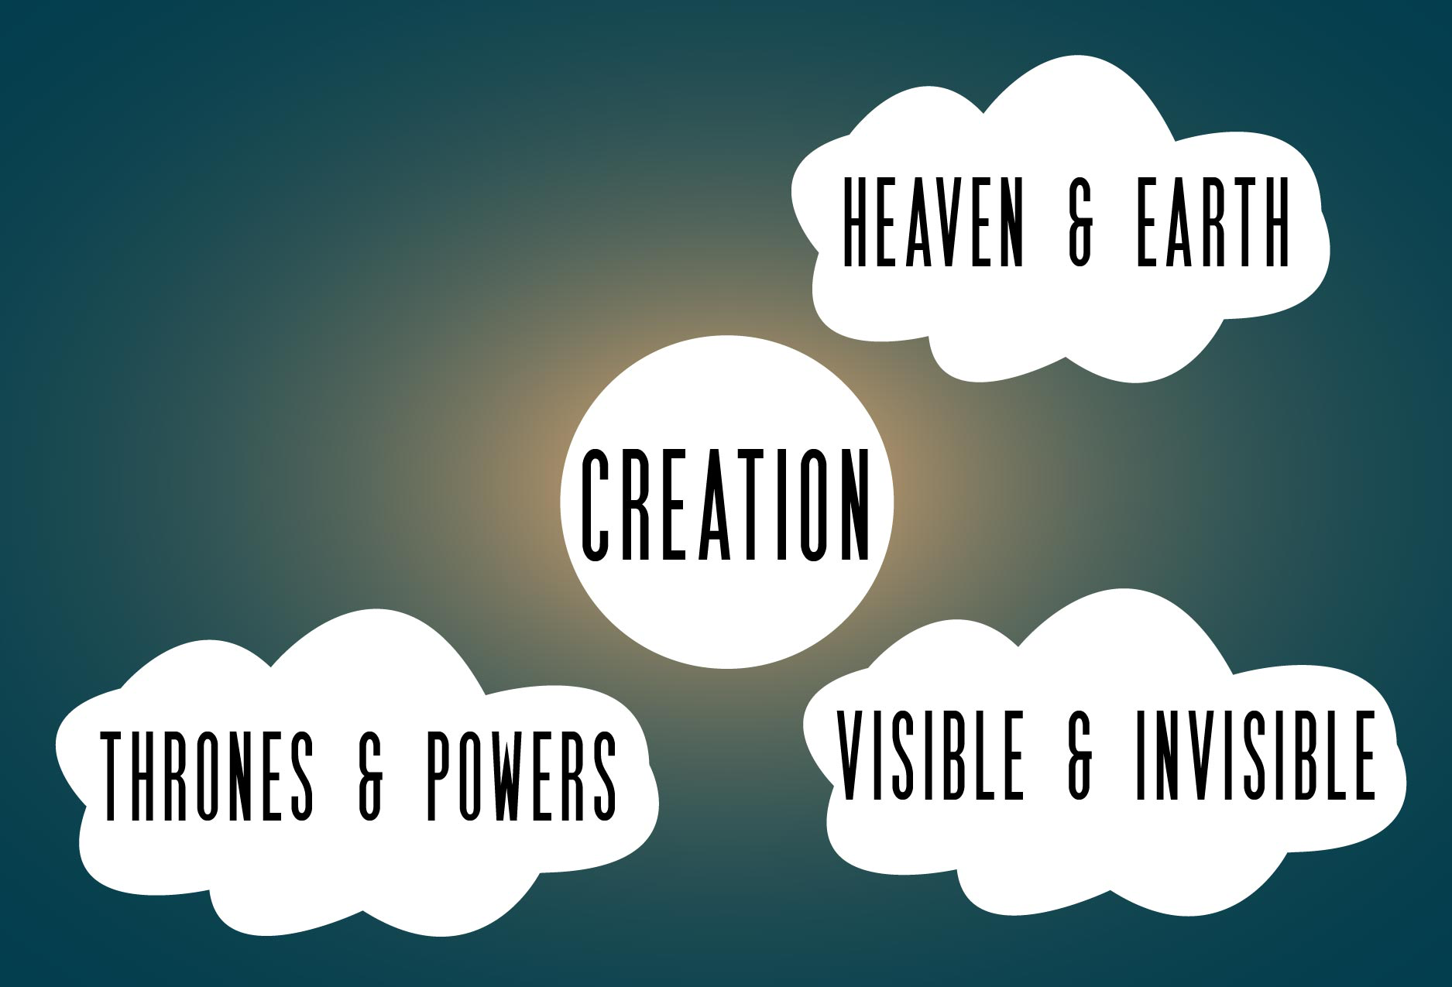

Or rulers or authorities
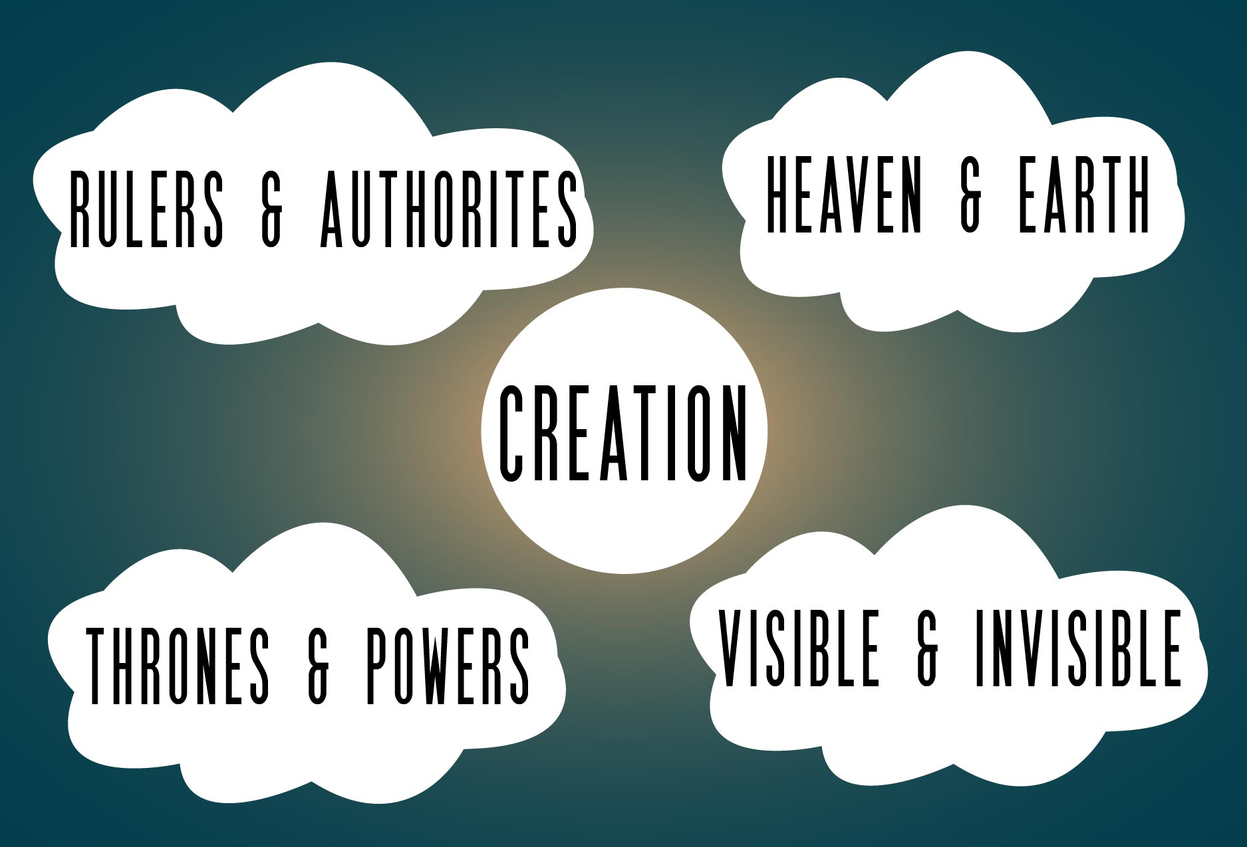

all things have been created through Him and for Him.

But Christ did not create all things and then leave creation to govern and guide itself. The cosmos was not created to exist in chaos, doing its own thing, going its own way, running willy-nilly around the universe causing chaos and confusion.

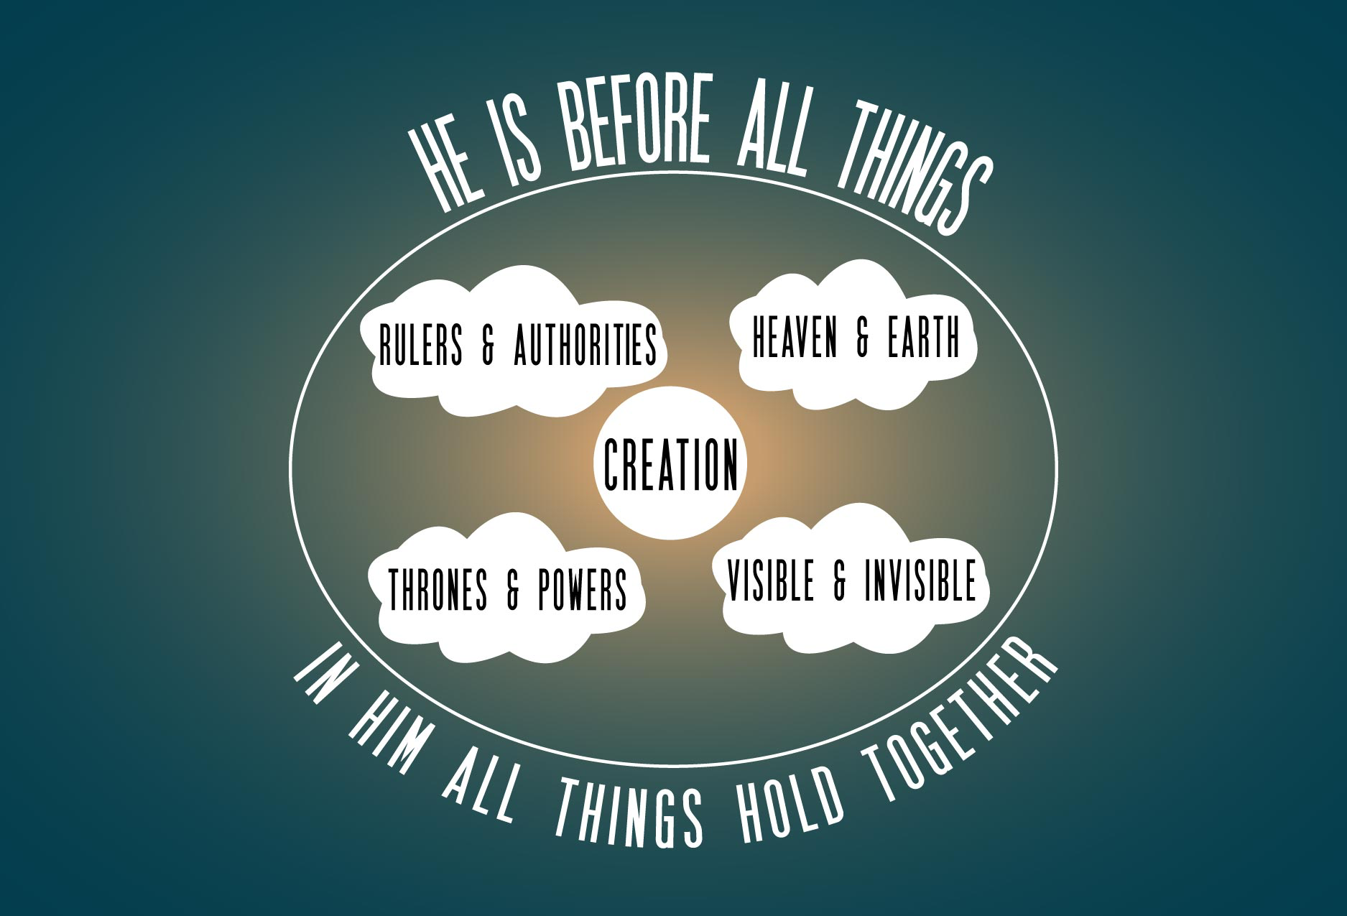

No! Christ is superior to all created things. He is before all things, and in Him all things hold together.

Christ is the Head of His Church

Since Christ is the head over all rule and authority then He is certainly the head over the body, the church. (2.10) Paul writes, “And He is the head of the body, the church;
He is the beginning and the firstborn from among the dead” (1.18a) If things in heaven and on earth, visible and invisible, whether thrones or powers or rulers or authorities; are all subject to Christ’s rule and authority doesn’t it make sense that the church should be subject to Christ as well? Christ is the head of the church, He Himself being the Savior of the body; therefore the church ought to be subject to Christ in everything. (Eph.5.23-24) Since Christ is the head of the church then His teaching has superiority not some mystic angel. Since Christ is the head of the church His directs us in all righteousness not some traditions concocted by mere men. The church should be “big-headed” not with foolish pride but because Christ has grown so large in our hearts and minds. Paul writes, “He is the beginning” showing that Christ is the origin and source of life of the church and every believer. Everything starts with Jesus. He is the Alpha.

He is the head of the body, but not only for this life but also for the life to come. Christ has been raised from the dead, the firstborn from among the dead. God raised Him up from the dead and by doing so put an end to the agony of death. Christ has been exalted to His rightful seat at the right hand of the Father to rule and reign forever and ever. As the firstborn from among the dead, Christ has defeated the power of death and He rules and reigns on high receiving blessing and honor and glory and dominion forever and ever. Amen.

In these three profound found in verses fifteen through eighteen the Apostle has shared the scope of Christ supremacy ranging from the Godhead, creation, and the church so that in everything Christ might have the supremacy in the mind and heart of the believer. (1.18b)

The Result of Christ’s Supremacy

After focusing on the scope of Christ supremacy, the Apostle will now focuses on the result of Christ’s supremacy. In typical Pauline fashion the Apostle will revisit each of the points he just made concerning the scope of Christ’s supremacy by showing the present result. The Apostle doesn’t want the believer to conclude that Christ’s supremacy only relates to the “out there” but he wants the believer to know that Christ’s supremacy relates to the believer “here and now?” Christ is and has been the image of the invisible God. Christ is and has been the creator and sustainer of the universe. Christ is and has been the Head of the Church. But how do those truths relate to the believer “here and now.”

As I mentioned, in typical Pauline fashion the Apostle revisits each of the points he just made showing the present result for the believer.

The first point that the Apostle made was that Christ was the image of the invisible God. Now he links that with the present result. Since Christ was the image of the invisible God (1.15a), it was the Father’s good pleasure for all the fullness to dwell in Him. (1.19)

The Son is the image of the invisible God . . . God was pleased to have all His fullness dwell in Him. (1.15a, 19)

The present result of the Son being the radiance of the Father’s glory and the exact representation of His nature is that we can enjoy the fullest of God through Christ. We don’t need a mediator. We don’t need visions. We don’t need extra religious rules and regulations to enjoy the fullest of God. We have Christ! Christ is enough! Christ is all I need! In Christ we can enjoy the fullness of God! Christ is our “all in all.”

Brothers and sisters, Jesus Christ fulfilled every dot and tittle of the Law. (Mt.5.18) Christ Jesus fulfilled all things written about the Son of God in the Law of Moses and the Prophets and the Psalms. (Lk.24.44) Jesus Christ fulfilled the Old Testament sacrificial system by offering His own blood with blemish to God for the forgiveness of our sins. (Heb.9.11-14) The eternal Son of God became flesh so that we could see the light of God’s glory fully revealed in the face of Christ. (2Cor.4.6)

The second point that the Apostle made was that Christ is the Creator and Sustainer of the universe. Now he links that with the present result. Since Christ is the Creator and Sustainer of the universe (1.15b-17), the Father will reconcile all things through Christ. (1.20)

The Son is over all creation . . . and through Him to reconcile to Himself all things (1.15b-17, 20)
The present result of Christ being over all creation is that all things will be reconciled through Christ. The believer knows that creation is in constant decay but according to His promise we are looking for the new heavens and new earth, in which righteousness dwells. (2Pt.3.13) Christ will reconcile all created things by establishing the new heavens and new earth at His second coming. In this fallen world we experience mourning, crying, and pain but Christ will make is all things new. He will reconcile all things so that there will be no more mourning, no more crying, and no more pain. And for the believer we will be changed in a moment, in the twinkling of the eye. For this perishable will have put on the imperishable, and this mortal will have put on immortality, because God has given us victory over death through our Lord Jesus Christ. (ICor.15.54-57)

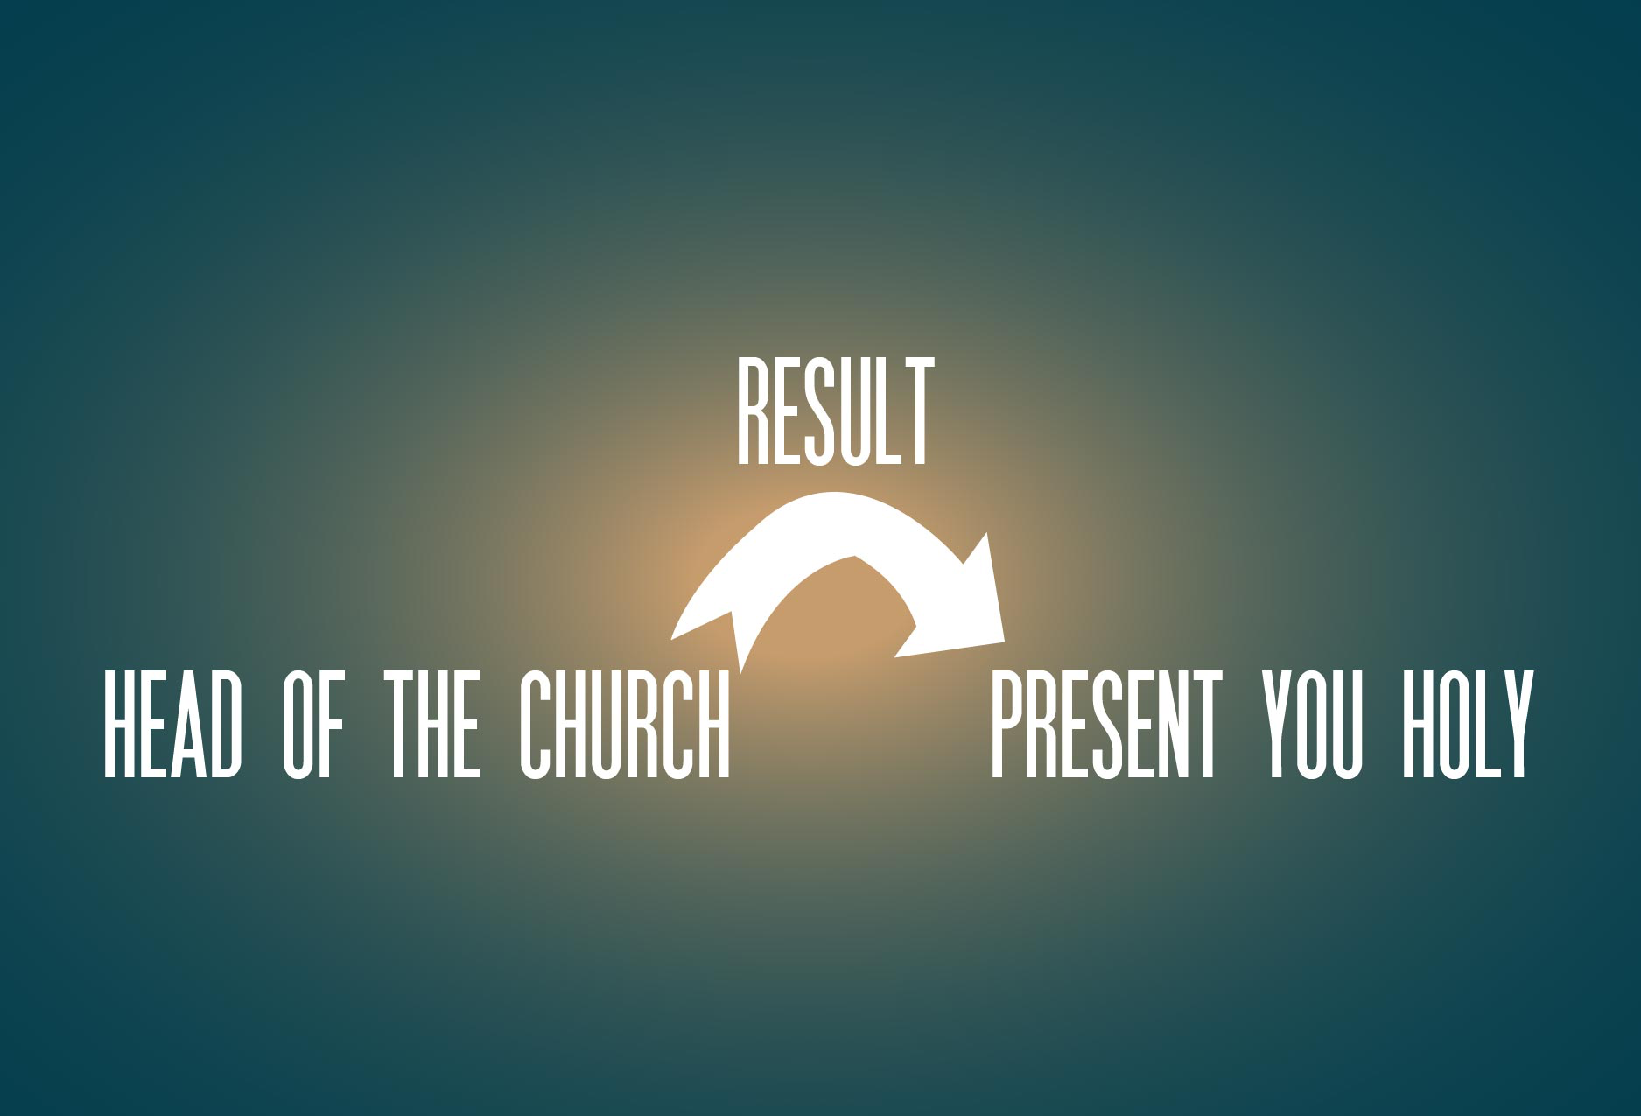

The last point the Apostle made was that Christ is the head of the church. Now he links that with the present result. Since Christ is the head of the church (1.18), we will be presented holy and blameless to the Father through Christ. (1.19-22)

He is the head of the church . . . to present you holy in His sight (1.18, 22)

If Christ is your head, if you are in Christ, then you will be presented holy and blameless to the Father. Once you were alienated from God and were enemies in your minds because of your evil behavior. ²² But now He has reconciled you by Christ’s physical body through death to present you holy in His sight, without blemish and free from accusation. (1.21-22) Who will bring a charge against God’s elect? God is the one who justifies; who is the one who condemns? Christ Jesus is He who died, yes, rather who was raised, who is at the right hand of God, who also intercedes for us. (Rom.8.33-34) Christ loves the church the church and gave Himself up for her, so that He might sanctify her, having cleansed her by the washing of water with the word, that He might present to Himself the church in all her glory, having no spot or wrinkle or any such thing; but that she would be holy and blameless. (Eph.5.25-27) The present result of Christ’s headship is that we would be sanctified and cleansed by the Word of God. This is what the believer should expect.

Closing Thoughts

Paul concludes this glorious passage by encouraging those in Christ at Colossae to continue in your faith, established and firm, and do not move from the hope held out in the gospel. (1.23)

What is the gospel? Jesus + nothing = The Gospel. The Apostle is encouraging those in Christ at Colossae not to add anything to the gospel but rather to embrace the message that they had heard from the beginning. Jesus + nothing = The Gospel. And this is my challenge for those of us in Christ at Christ Covenant Church.

Continue in your faith, established and firm, and do not move from the hope held out in the gospel. (1.23) Exalt Christ as supreme in everything in your life!

Call to Prayer

sanctify Christ as Lord in your hearts (IPt.3.15a)

